International Cybersecurity and Digital Forensics Academy (ICDFA)
SBT-DF203: Basic Networking Skills for Digital Forensics
LAB 7: DNS Introduction and Traffic Analysis

Mba, Chimdi Ufere
202573556GF

LAB 1

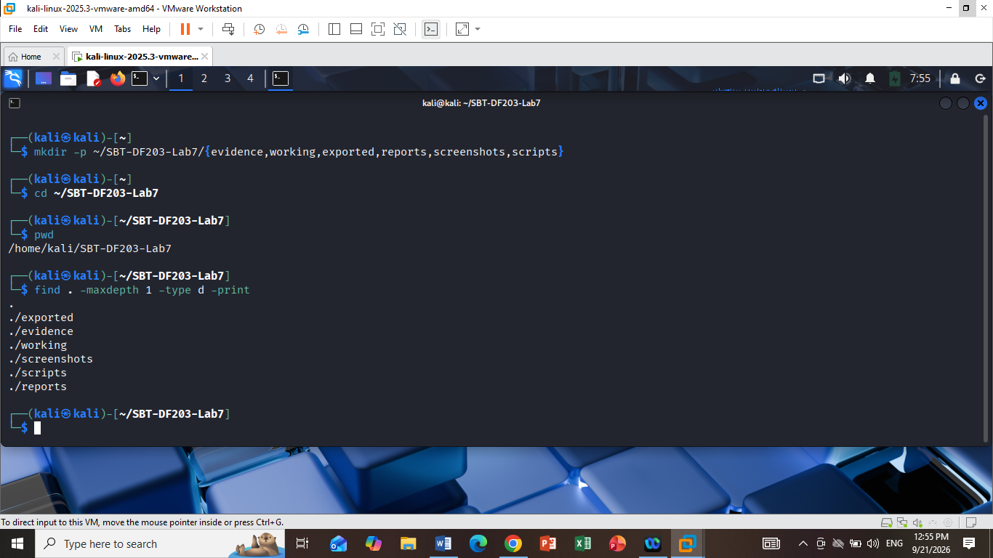

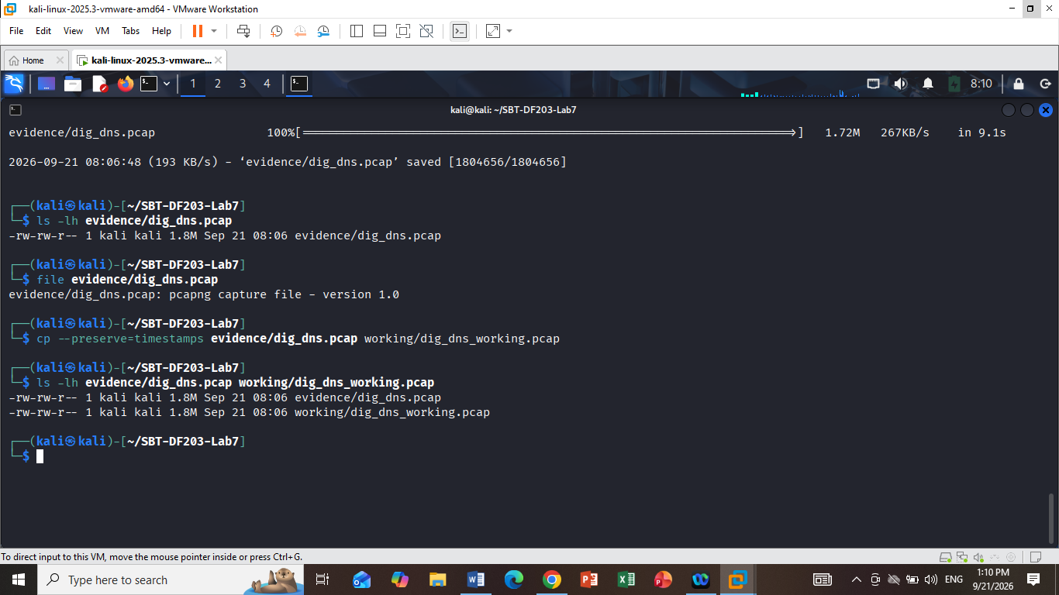

Lab 6
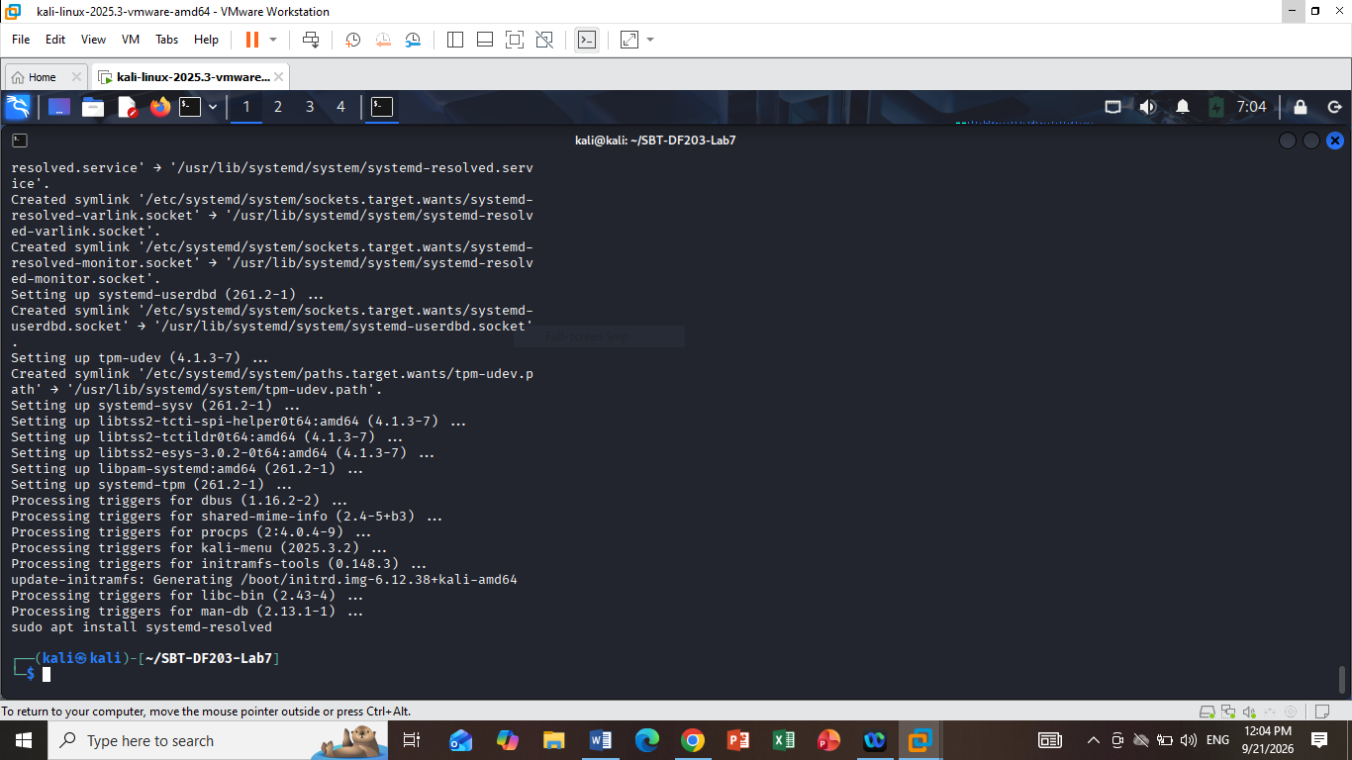

LAB 7

7. Mini Evidence and Chain-of-Custody Worksheet
Field | Student Entry
Case/lab identifier | SBT-DF203-Lab7-YourFullName
Trainee name | MBA CHIMDI
Date and time started | Mon Sep 21 07:09:29 AM EDT 2026
Evidence file name(s) | dig_dns.pcap
Source or generation method | Downloaded from the instructor-provided digital-forensics lab repository using wget.
Original SHA-256 | 9a7c1b95aa6d60f8ac0ee9a79e06ae51145bb7768974526546316cd3dc91375d evidence/dig_dns.pcap
Working-copy SHA-256 | 9a7c1b95aa6d60f8ac0ee9a79e06ae51145bb7768974526546316cd3dc91375d working/dig_dns_working.pcap
Analysis workstation/VM | Kali Linux VM
Notes on any changes | Original preserved in evidence/; working copy created in working/ with timestamps preserved; SHA-256 hashes verified

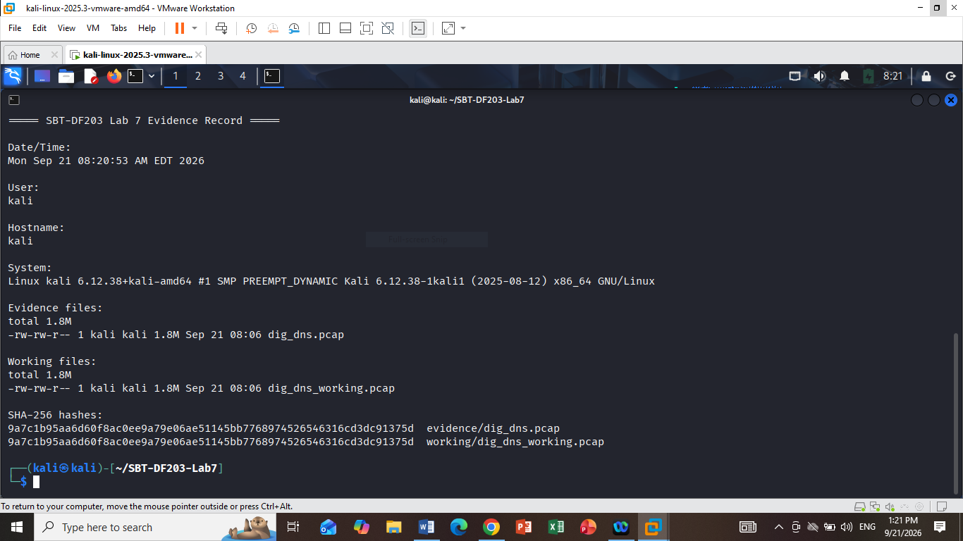

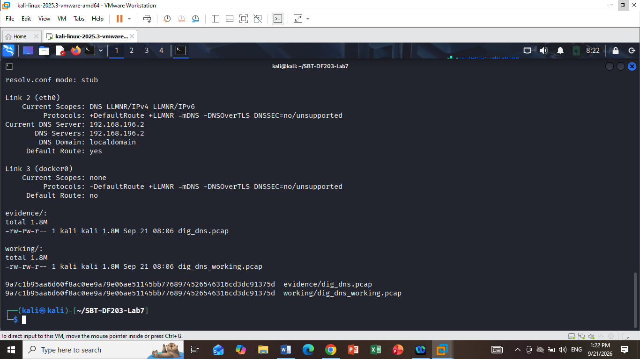

Lab 8

A record

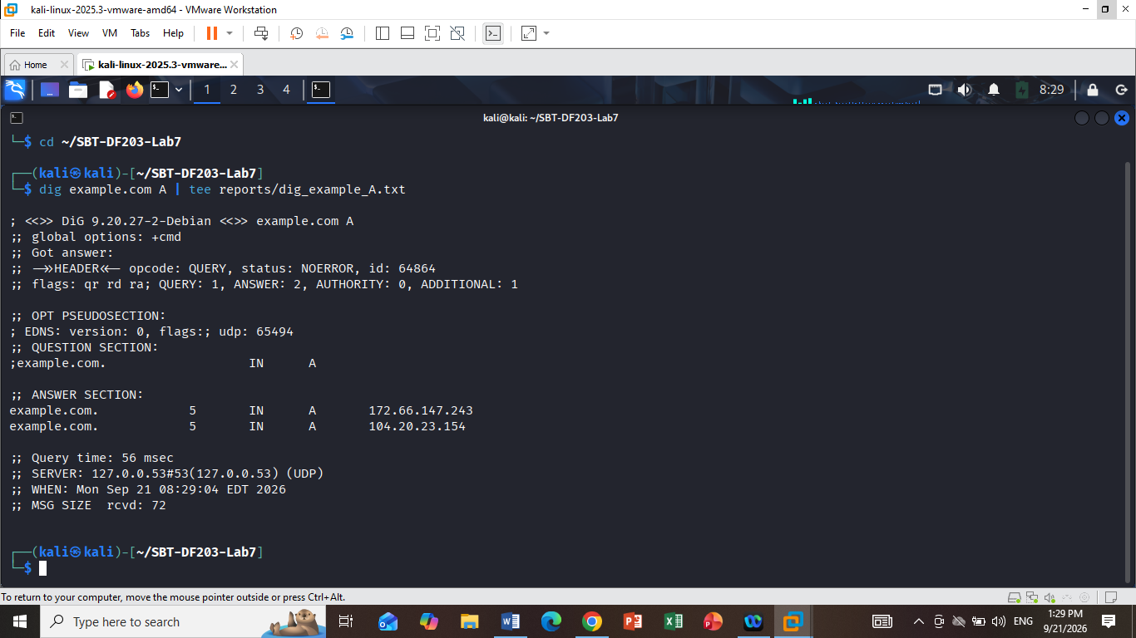
dig example.com AAAA | tee reports/dig_example_AAAA.txt

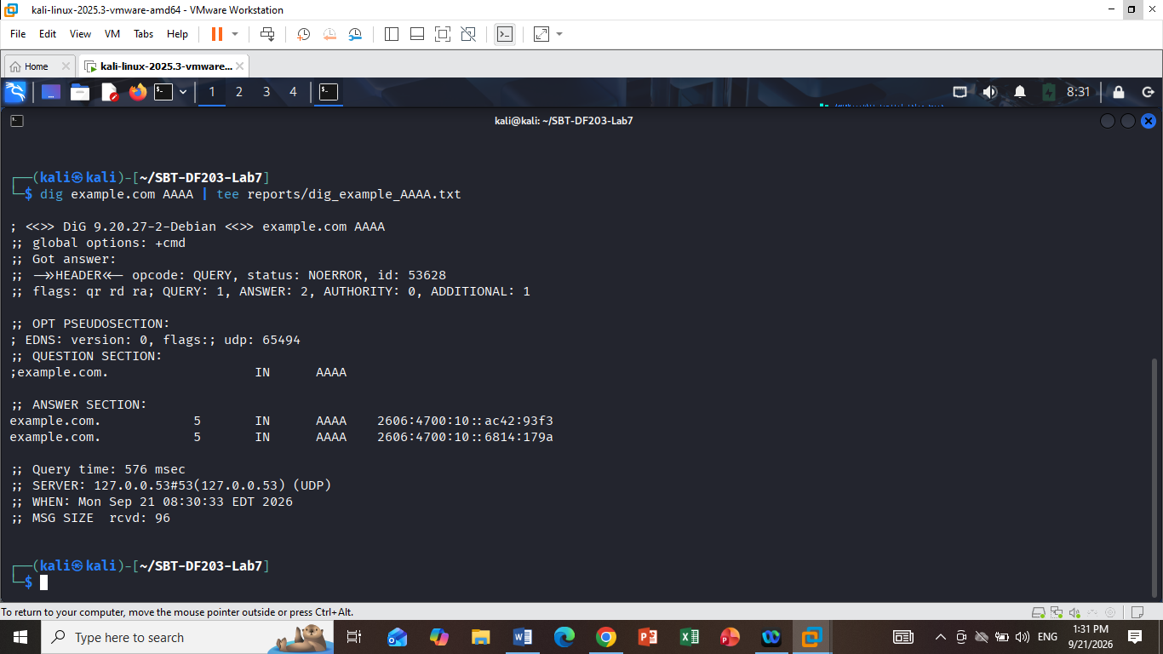
dig example.com MX | tee reports/dig_example_MX.txt
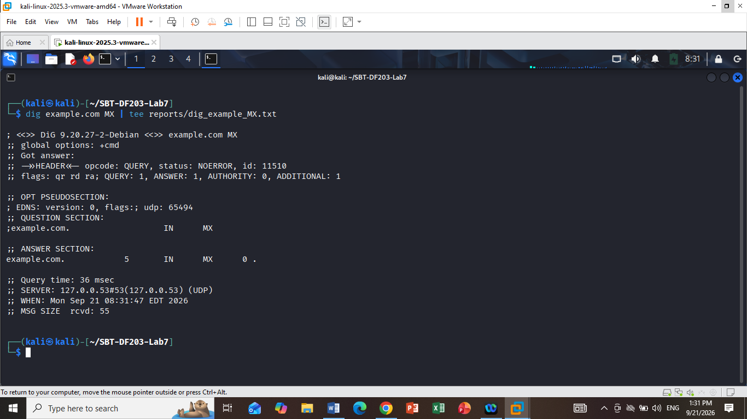
dig example.com NS | tee reports/dig_example_NS.txt
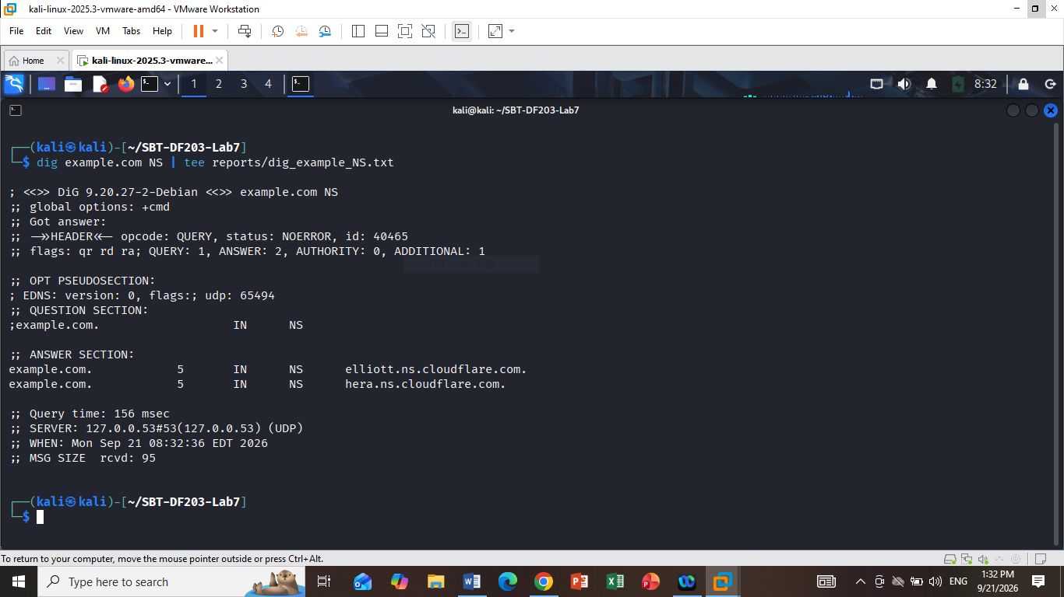

dig +short example.com A | tee reports/dig_example_short.txt

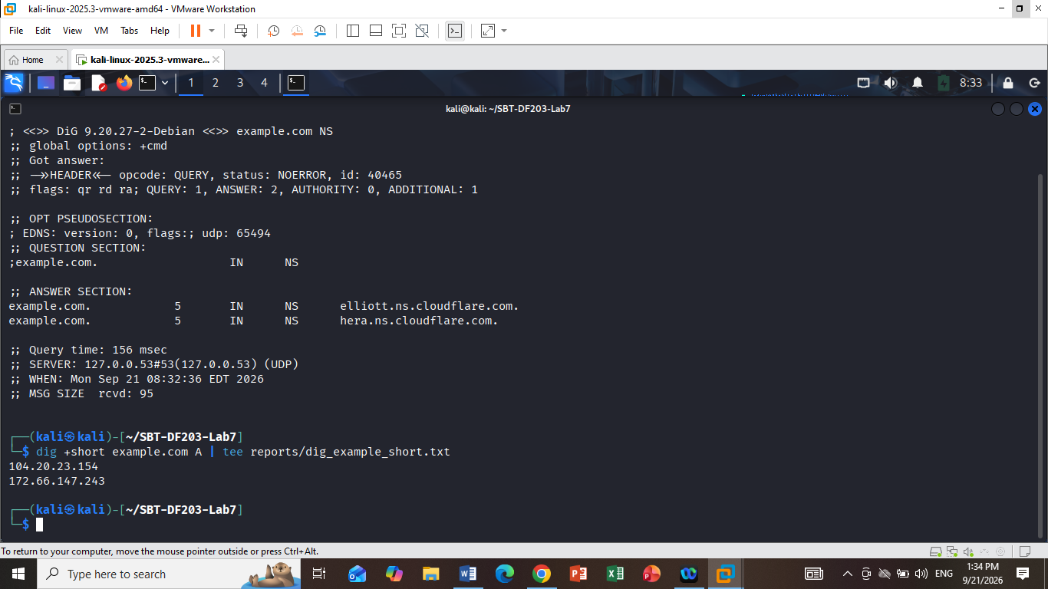

Item | What to record
Resolver | The SERVER: line
Status | NOERROR, NXDOMAIN, etc.
Transaction ID | Number after id:
Flags | e.g. qr rd ra
Question count | QUERY:
Answer count | ANSWER:
Query time | Query time:
TTL | Number before IN
Answer | IP/domain returned

Meaning of the record types
- IN = Internet class.
- A = IPv4 address.
- AAAA = IPv6 address.
- MX = Mail Exchange server for the domain.
- NS = Authoritative name server for the domain.

Lab9
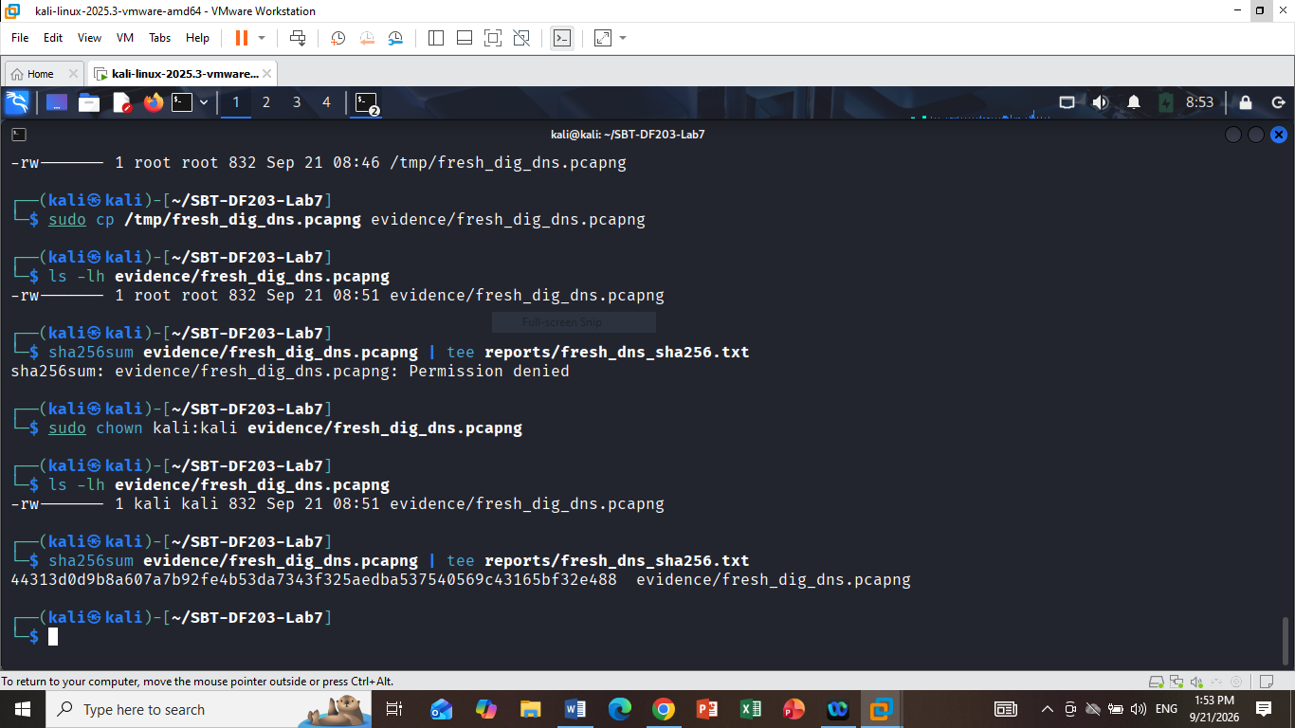

1. Your DNS query results
Frame | Time | Source | Destination | Transaction ID | Query | Type
1 | 08:46:37.977491715 | 192.168.196.132:50085 | 192.168.196.2:53 | 0x3d5e | example.com | A
3 | 08:46:38.512507789 | 192.168.196.132:50085 | 192.168.196.2:53 | 0x29f9 | example.com | A

2. Your DNS response results
Frame | Time | Source | Destination | Transaction ID | RCODE | Answers | TTL
2 | 08:46:38.511958935 | 192.168.196.2:53 | 192.168.196.132:50085 | 0x3d5e | 0 | 172.66.147.243, 104.20.23.154 | 5, 5
4 | 08:46:38.519177480 | 192.168.196.2:53 | 192.168.196.132:50085 | 0x29f9 | 0 | 104.20.23.154, 172.66.147.243 | 5, 5
RCODE 0 = NOERROR, meaning the DNS queries were successfully answered.

3. Part D — Match queries to responses
We can now match them using the transaction ID and the client/resolver addresses.
The response times are:
- 0x3d5e: approximately 0.534467 ms
- 0x29f9: approximately 6.670 ms
Transaction ID | Query Name | Type | Client/Resolver | Response Code | Answer(s)
  TTL
  Time Delta
0x3d5e | example.com | A | 192.168.196.132 → 192.168.196.2 |  | 172.66.147.243, 104.20.23.154 | 5 s | 0.534 ms
  NOERROR (0)
 | example.com | A | 192.168.196.132 → 192.168.196.2 |  | 104.20.23.154, 172.66.147.243 | 5 s | 6.670 ms
  0x29f9
  NOERROR (0)

4. One important point for your report
Your timestamps contain -0400:
2026-09-21T08:46:37.977491715-0400
That is the timestamp timezone recorded by the capture. The time difference is what matters for the DNS

My text file
cat > reports/dns_query_response_analysis.txt <<'EOF'
DNS Query-to-Response Analysis
==============================

Transaction ID: 0x3d5e
Query: example.com
Type: A
Client: 192.168.196.132:50085
Resolver: 192.168.196.2:53
Response Code: 0 (NOERROR)
Answers: 172.66.147.243, 104.20.23.154
TTL: 5 seconds
Response Time: approximately 0.534 ms

Transaction ID: 0x29f9
Query: example.com
Type: A
Client: 192.168.196.132:50085
Resolver: 192.168.196.2:53
Response Code: 0 (NOERROR)
Answers: 104.20.23.154, 172.66.147.243
TTL: 5 seconds
Response Time: approximately 6.670 ms

Matching Method:
Queries were matched to responses using the DNS transaction ID
and the corresponding client/resolver endpoint tuple.

Observation:
Both queries received successful NOERROR responses. Each response
contained two A records with a TTL of 5 seconds.
EOF

11. Part D — Match Queries to Responses
Transaction ID | Query Name | Type | Client/Resolver | Response Code | Answer(s) | TTL
  Time Delta
0x3d5e |  | A | 192.168.196.132:50085 → 192.168.196.2:53 |  | 172.66.147.243, 104.20.23.154 | 5 s | 0.534 ms
  example.com
  0 (NOERROR)
0x29f9 |  | A | 192.168.196.132:50085 → 192.168.196.2:53 | 0 (NOERROR | 104.20.23.154, 172.66.147.243 | 5 s
  example.com

Note; The DNS queries were matched to their corresponding responses using the DNS transaction ID and endpoint tuple. The queried resolver was 192.168.196.2 on UDP port 53. Both queries for example.com returned NOERROR responses containing two A records. The TTL for each returned A record was 5 seconds. No CNAME chain or AAAA answer was observed in this capture

